Daniyal Ahmad F20232661112

Software Project Management – Assignment 3

Course: Software Project Management

Section: V1

# 1. Introduction

This project involves the development of a scalable e-commerce platform featuring user authentication, a product catalog, payment gateway integration, and order tracking. The objective is to follow standard software project management practices including planning, estimation, risk analysis, and performance tracking to ensure successful delivery within a 12-week schedule.

# 2. Methodology

The project was planned and managed using key tools and techniques:  
- WBS and Gantt Chart: Defined tasks, durations, and timelines.  
- COCOMO II (Organic Mode): Used for effort estimation based on 55 KLOC.  
- Risk Management: Identified and mitigated 5 key risks.  
- Resource Allocation: Team of 4 developers, 2 testers, 1 PM.  
- Project Monitoring: Used Earned Value Management (EVM) to track progress.

# 3. Results

## 3.1 Work Breakdown Structure (WBS)

1. Project Initiation  
 1.1 Requirements Gathering  
 1.2 Feasibility Analysis  
  
2. Design  
 2.1 System Architecture Design  
 2.2 UI/UX Design  
  
3. Development  
 3.1 User Authentication  
 3.2 Product Catalog  
 3.3 Payment Gateway  
 3.4 Order Tracking  
  
4. Testing  
 4.1 Unit Testing  
 4.2 Integration Testing  
 4.3 System Testing  
  
5. Deployment  
 5.1 Server Setup  
 5.2 Final Deployment  
  
6. Maintenance  
 6.1 Bug Fixes  
 6.2 Minor Enhancements

## 3.2 Gantt Chart

The Gantt chart for the project is shown below:

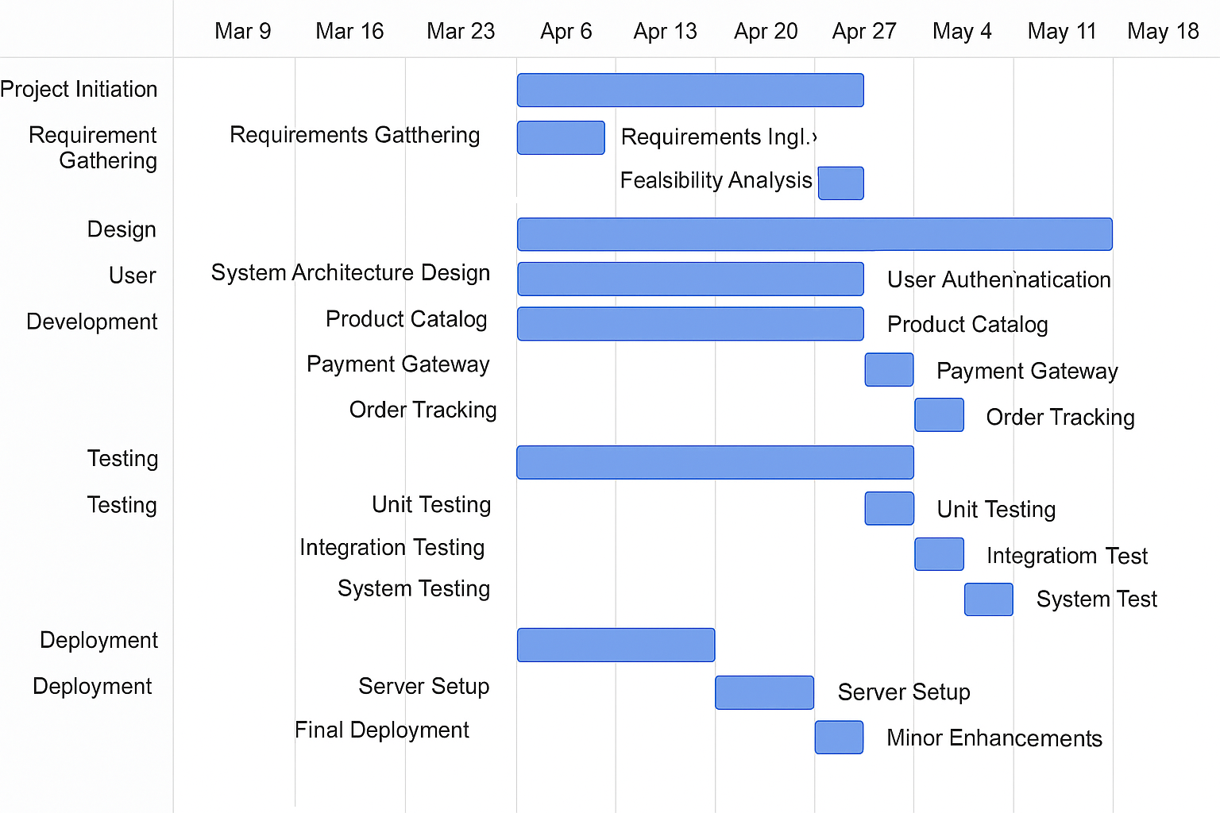

## 3.3 Effort Estimation using COCOMO II

Mode: Organic  
KLOC: 55  
Formula: Effort = 2.4 × (KLOC)^1.05  
Calculation: Effort = 2.4 × 55^1.05 ≈ 148.17 person-months

## 3.4 Risk Register

|  |  |  |  |  |
| --- | --- | --- | --- | --- |
| Risk ID | Description | Impact | Likelihood | Mitigation Strategy |
| R1 | Developer attrition | High | Medium | Maintain documentation and backups |
| R2 | Payment gateway API changes | Medium | High | Regular API updates, fallback plans |
| R3 | Scope creep | High | Medium | Freeze requirements early |
| R4 | Data breach/security vulnerabilities | High | Low | Use secure coding and encryption |
| R5 | Server downtime during deployment | Medium | Medium | Use cloud-based failover systems |

## 3.5 Resource Allocation

Role | Count | Duration (Weeks) | Responsibility  
-------------- | ------| ---------------- | -------------------------------  
Developers | 4 | 12 | Coding, Unit Testing  
Testers | 2 | 6 (Weeks 6–12) | Integration/System Testing  
Project Manager| 1 | 12 | Planning, Monitoring, Control

## 3.6 Monitoring & Control (EVM – Week 6)

Given:  
- PV = $60,000  
- EV = $50,000  
- AC = $65,000  
  
Calculations:  
Cost Variance (CV) = EV - AC = -15,000  
Schedule Variance (SV) = EV - PV = -10,000  
Cost Performance Index (CPI) = EV / AC = 0.77  
Schedule Performance Index (SPI) = EV / PV = 0.83  
  
Interpretation:  
- CV < 0: Over budget  
- SV < 0: Behind schedule  
- CPI < 1: Cost inefficiency  
- SPI < 1: Schedule inefficiency  
  
Corrective Actions:  
- Reallocate tasks or increase developer hours  
- Review and optimize resource usage  
- Reduce scope or phase features into later updates  
- Conduct weekly performance reviews to stay on track

# 4. Conclusion

This assignment simulated a real-world e-commerce project from planning through monitoring. By applying structured estimation, planning, and control techniques, we identified gaps in schedule and cost performance early, allowing for corrective measures. Tools like Gantt charts and EVM metrics proved essential in managing scope, time, and resources.